DAY -9

1) .Create AFTER UPDATE trigger to track product price changes.

**QUERY:**

**Create Table for logging:**

CREATING TABLE CREATE TABLE product_price_log

( log_id SERIAL PRIMARY KEY,

product_id INT, old_price NUMERIC,

new_price NUMERIC,

changed_at TIMESTAMP DEFAULT CURRENT_TIMESTAMP );

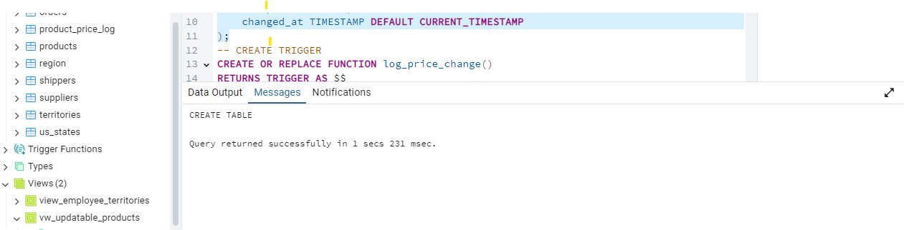

Create Trigger Function:

CREATE OR REPLACE FUNCTION log_price_change()

RETURNS TRIGGER AS $$

BEGIN

IF OLD.unit_price <> NEW.unit_price

THEN INSERT INTO product_price_log (product_id, old_price, new_price)

VALUES (OLD.product_id, OLD.unit_price, NEW.unit_price);

END IF;

RETURN NEW;

END;

$$

LANGUAGE plpgsql;

**Output:**

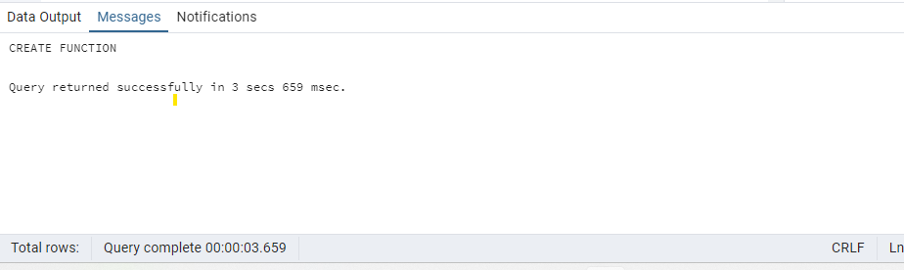

**Create the trigger on the products table**

CREATE TRIGGER after_price_update

AFTER UPDATE ON products

FOR EACH ROW EXECUTE FUNCTION log_price_change();

Output:

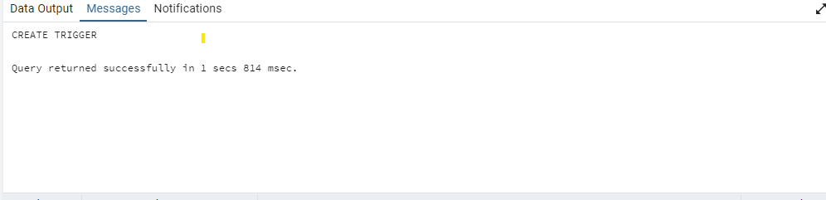

**Update price by 10% and verify the audit log:**

**QUERY:**

UPDATE products SET unit_price = unit_price * 1.10 WHERE product_id = 1;

SELECT * FROM product_price_log WHERE product_id = 1;

**OUTPUT:**

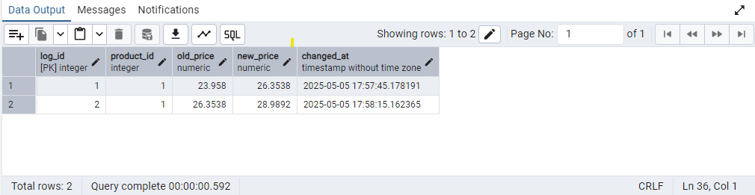

2) Create stored procedure using IN and INOUT parameters to assign tasks to employees

**Query:**

CREATE TABLE IF NOT EXISTS employee_tasks (

task_id SERIAL PRIMARY KEY,

employee_id INT,

task_name VARCHAR(50),

assigned_date DATE DEFAULT CURRENT_DATE)

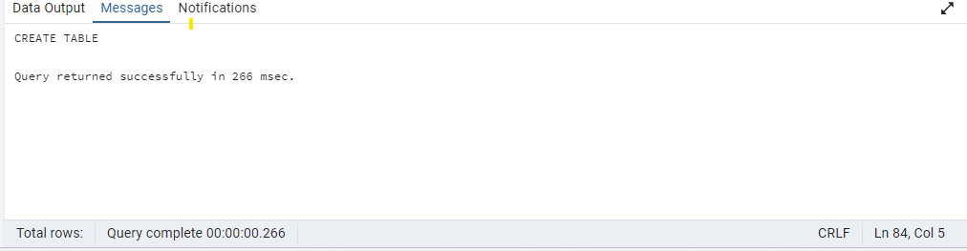

CREATE OR REPLACE PROCEDURE assign_task(

IN p_employee_id INT,

IN p_task_name VARCHAR(50),

INOUT p_task_count INT DEFAULT 0

)

LANGUAGE plpgsql

AS $$

BEGIN

INSERT INTO employee_tasks (employee_id, task_name)

VALUES (p_employee_id, p_task_name);

SELECT COUNT(*) INTO p_task_count

FROM employee_tasks

WHERE employee_id = p_employee_id;

RAISE NOTICE 'Task "%" assigned to employee %. Total tasks: %',

p_task_name, p_employee_id, p_task_count;

END;

$$;

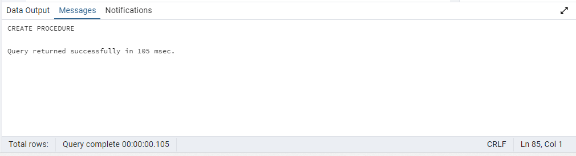

CALL assign_task(1, 'Review Reports', 0);

DO $$

DECLARE

task_count INT := 0;

BEGIN

CALL assign_task(1, 'Prepare Presentation', task_count);

CALL assign_task(1, 'Attend Meeting', task_count);

END; $$

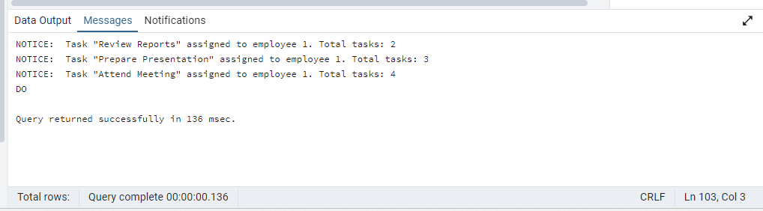

SELECT * FROM employee_tasks ORDER BY task_id;

